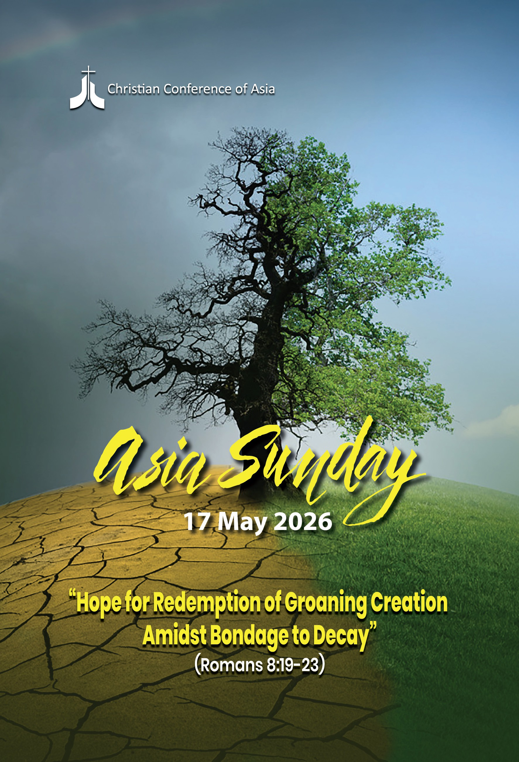

Foreword

The Asia Sunday 2026 theme is “Hope for Redemption of Groaning Creation Amidst Bondage to Decay”. Once again, CCA calls its member constituencies to reflect and pray together on this special occasion of the observance of Asia Sunday, to respond to the groaning of creation, seek liberation from the decaying experiences of the whole creation, and beseech God’s intervention.
“The groaning of the creation” is a biblical metaphor (Romans 8:22) which illustrates the agonising condition of decay and bondage, comparing it to the suffering of pain and decay, but this suffering is purposeful like the pain of childbirth, ultimately leading to new life.
In his epistle to the Romans, Paul describes the present state of creation: it is subjected to futility and is in bondage to corruption. It represents the natural world’s longing for liberation and eventual restoration, signalling hope for new life, healing, and the final redemption of all things. It refers to the ultimate and complete restoration of all creation to its rightful state, free from the effects of sin.
The hope of redemption encourages believers to reflect on and understand the current state of degeneration in different areas, including environmental decay and personal suffering. Such conditions need not be considered as final or hopeless, but rather as a transitional phase towards an absolute, divine renewal and revitalisation of the entire cosmos. It is viewed as the culmination of God's redemptive plan. The theme of this year’s Asia Sunday focuses on some of these pressing realities and challenges.
Asia Sunday is observed every year on the Sunday before Pentecost; in 2026, it falls on 17 May. CCA member churches, member councils, and ecumenical organisations within the fraternity are requested to observe this year’s Asia Sunday on 17 May 2026.
May God’s abundant blessings give us “Hope for Redemption of Groaning Creation Amidst Bondage to Decay”.
Yours along the journey,
Mathews George Chunakara
General Secretary, CCA

ASIA SUNDAY 2026

“Hope for Redemption of Groaning Creation Amidst Bondage to Decay”

INTRODUCTION
Asia today is navigating a high-stakes convergence of social, economic, political, environmental, and spiritual crises that affect the lives of Asian people. These include conflicts and violence, political and economic instability, unemployment, rampant militarisation, environmental collapse, cultural fragmentation, inadequate healthcare, and the impacts of rapid technological advancement. Moreover, the alarming trend of environmental degradation and climate change is fundamentally threatening not only the daily life of humans but also causing the whole creation to groan and suffer: degeneration of the environment, depletion of natural resources, poor quality of air, water, and soil, devastation of ecosystems, ecological imbalances, and increased global warming. All these indicate the fact that “the whole creation has been groaning”. (Romans 8:22)
Although the whole creation groans, believers groan, and the Holy Spirit groans, Paul in Romans 8 assures us that “there is now no condemnation for those who are in Christ Jesus”, which comforts us by affirming that a Spirit-filled life in hope and perseverance will be set free from the law of sin and death (Romans 8:1-2).
As the whole cosmos is designed and created by God, people and all aspects of nature exist in a close relationship with God and with God’s creation. God, the Creator, the Maker of heaven and earth, sustains the whole creation, and God’s nature sustains humans living in this cosmos. Therefore, the church is called to contribute to a just and sustainable environment and to maintain the integrity of creation, in hope of God’s care, concern, assurances, and the redemption of groaning creation amidst bondage to decay.

ASIA SUNDAY 2026

Order of Worship

“Hope for Redemption of Groaning Creation Amidst Bondage to Decay”
(Romans 8:19-23)

(Elements on the altar: A beautifully decorated and creative altar/worship space may be prepared with elements depicting creation: flowers, plants, a basin or jar full of water, a lighted lamp or candle)

Gathering
Lord of life and peace,
in hope for redemption, we come to You.
Let Your Spirit set us free from all bonds of our sins,
so that our minds may be governed by the Spirit,
and be filled with new life and peace.
Amen.

Call to Worship
Blessed are the poor in spirit,
for theirs is the kingdom of heaven.
Blessed are those who mourn,
for they will be comforted.
Blessed are the meek,
for they will inherit the earth.
Blessed are those who hunger and thirst for righteousness,
for they will be filled.
Blessed are the merciful,
for they will be shown mercy.
Blessed are the pure in heart,
for they will see God.
Blessed are the peacemakers,
for they will be called children of God.
Blessed are those who are persecuted because of righteousness,
for theirs is the kingdom of heaven.

Make a joyful noise to the Lord, all the earth; break forth into joyous song and sing praises.
Let the sea roar, and all that fills it; the world and those who live in it.
Let the floods clap their hands; let the hills sing together for joy. (Psalm 98:4,7-8)
Righteousness and justice are the foundation of our God’s Kingdom. (Psalm 89:14)

- Praise the LORD
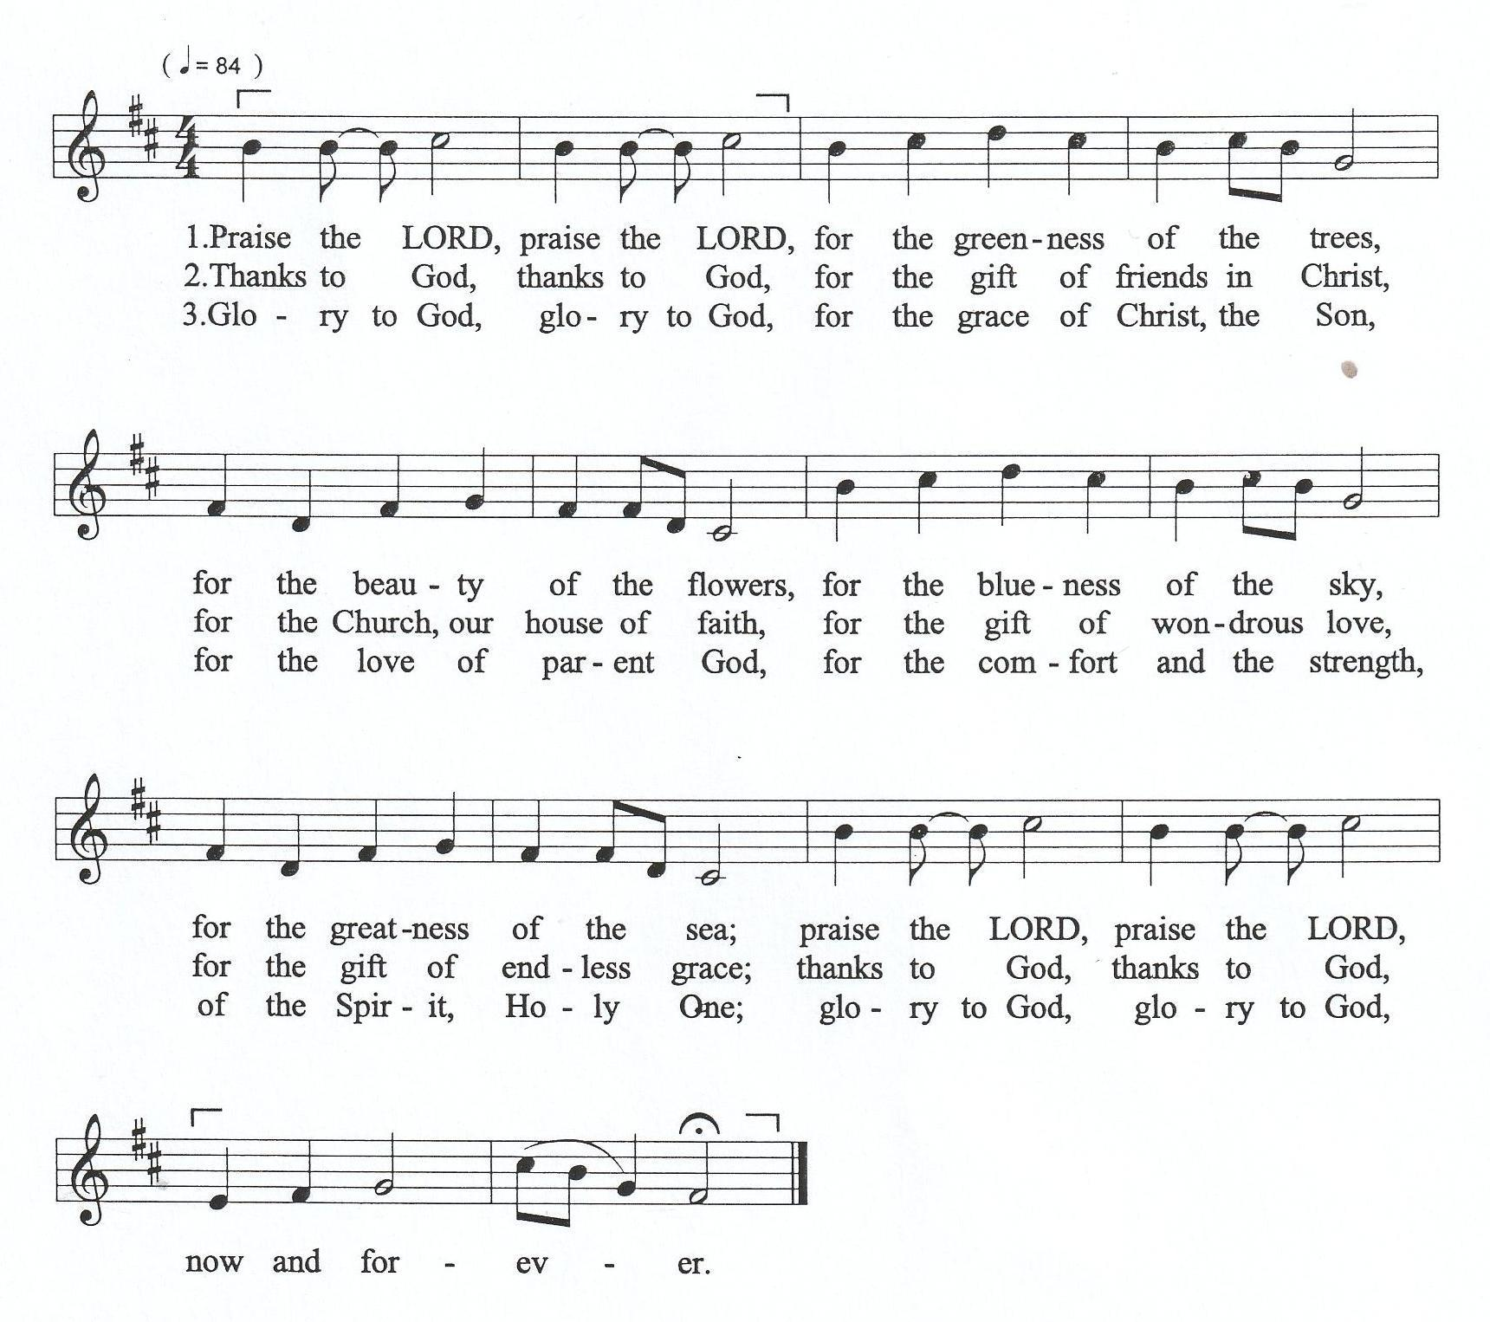

Lord of life and peace,
As we gather together, we invite Your presence into our midst.
Fill us with peace, wisdom, and a spirit of unity. Amen.

- O Give Praise to Jesus, the King

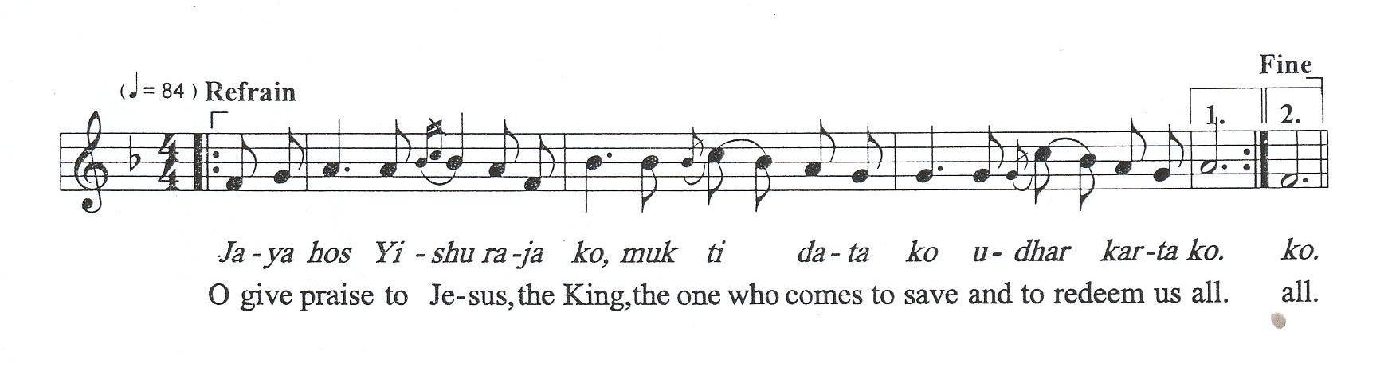

Prayer of Confession and Lament
God, we confess our neglect of the groaning creation:

“As of early 2026, Asia remains the epicentre of the global environmental crisis, grappling with some of the highest pollution levels in recorded history. Air pollution is the most visible and deadly environmental threat in Asia. In February 2026, real-time data indicated that nine out of the ten most polluted cities in the world were located in South and Southeast Asia. Asia is currently warming nearly twice as fast as the global average, making it the most disaster-prone region in the world. As of 2026, the intersection of rising temperatures, shifting monsoon patterns, and melting glaciers has created a "new normal" of high-frequency, high-impact natural disasters. The increasing climate extremes, like monsoons and heatwaves, are becoming more frequent, unpredictable and severe, displacing over a million people as internal climate refugees, forcing them to migrate from flooded or drought-stricken rural areas into already overcrowded cities.”

God, we confess economic injustice and our neglect of the vulnerable:

“While many nations in Asia have achieved record-breaking economic growth and poverty reduction, these gains are being threatened by rapid demographic shifts, deepening inequality, and environmental decay. The ‘wealth gap’ is widening, leaving many in informal employment, lacking health insurance or job security. Thousands of people are trafficked into ‘scam compounds’ – transnational cyber-scam hubs, particularly in the Mekong region. This unique ‘cyber slavery’ is forcing trafficked people to conduct online fraud under the threat of violence, which is closely tied to the global digital economy, making it difficult to track and even harder to dismantle.”

God, we confess our negligence in caring for our neighbours who are struggling with mental health:

“Asia accounts for approximately 60% of global suicides. Especially, Southeast Asia has a disproportionately high suicide rate, particularly among young women, often linked to socio-cultural stressors rather than solely mental disorders. Mental health issues like depression and high stress are rising, particularly among youth. Mental health issues are rising significantly across Asia, with high numbers of people living with a mental, neurological, or substance use condition. Driven by high stress, rapid urbanisation, and stigma, conditions like anxiety and depression are increasing.”

We confess that we have not loved You with our whole heart, nor have we loved our neighbours as ourselves. We confess that we have too often lived by our own selfish impulses, ignoring the cries of our children and youth who are in a more vulnerable situation.

“Young people are among the most vulnerable groups in Asia. Rising unemployment, climate disasters, forced migration, statelessness, trafficking, gender-based violence, extremist ideologies, and harmful spiritual trends have placed Asian youth at existential risk. Many also struggle with mental health crises, loneliness, digital addiction, and identity confusion in societies where traditional support systems are weakening.”

We have allowed the systemic injustices of our world—racism, greed, and oppression—to continue without our protest.

We confess that we have enjoyed abundance while turning a blind eye to the hungry, the homeless, and the vulnerable.
Forgive us, O God, for our silence in the face of injustice and our complicity in structures that destroy lives.

Give us the intelligence to know Your will,
the courage to do Your will,
and the devotion to love Your will.
O God, have mercy on us.

Assurance
Sisters and brothers,
we have a duty.
Our duty is not to live under the power of sin.
If we live under the power of sin, we will die.
But by the Spirit’s power, we will be renewed and restored, liberated from all bondage to decay.
Those whom the Spirit of God leads are children of God. (Romans 8:12-14)
Amen. Thanks be to God.

- Jesus Christ Sets Free to Serve
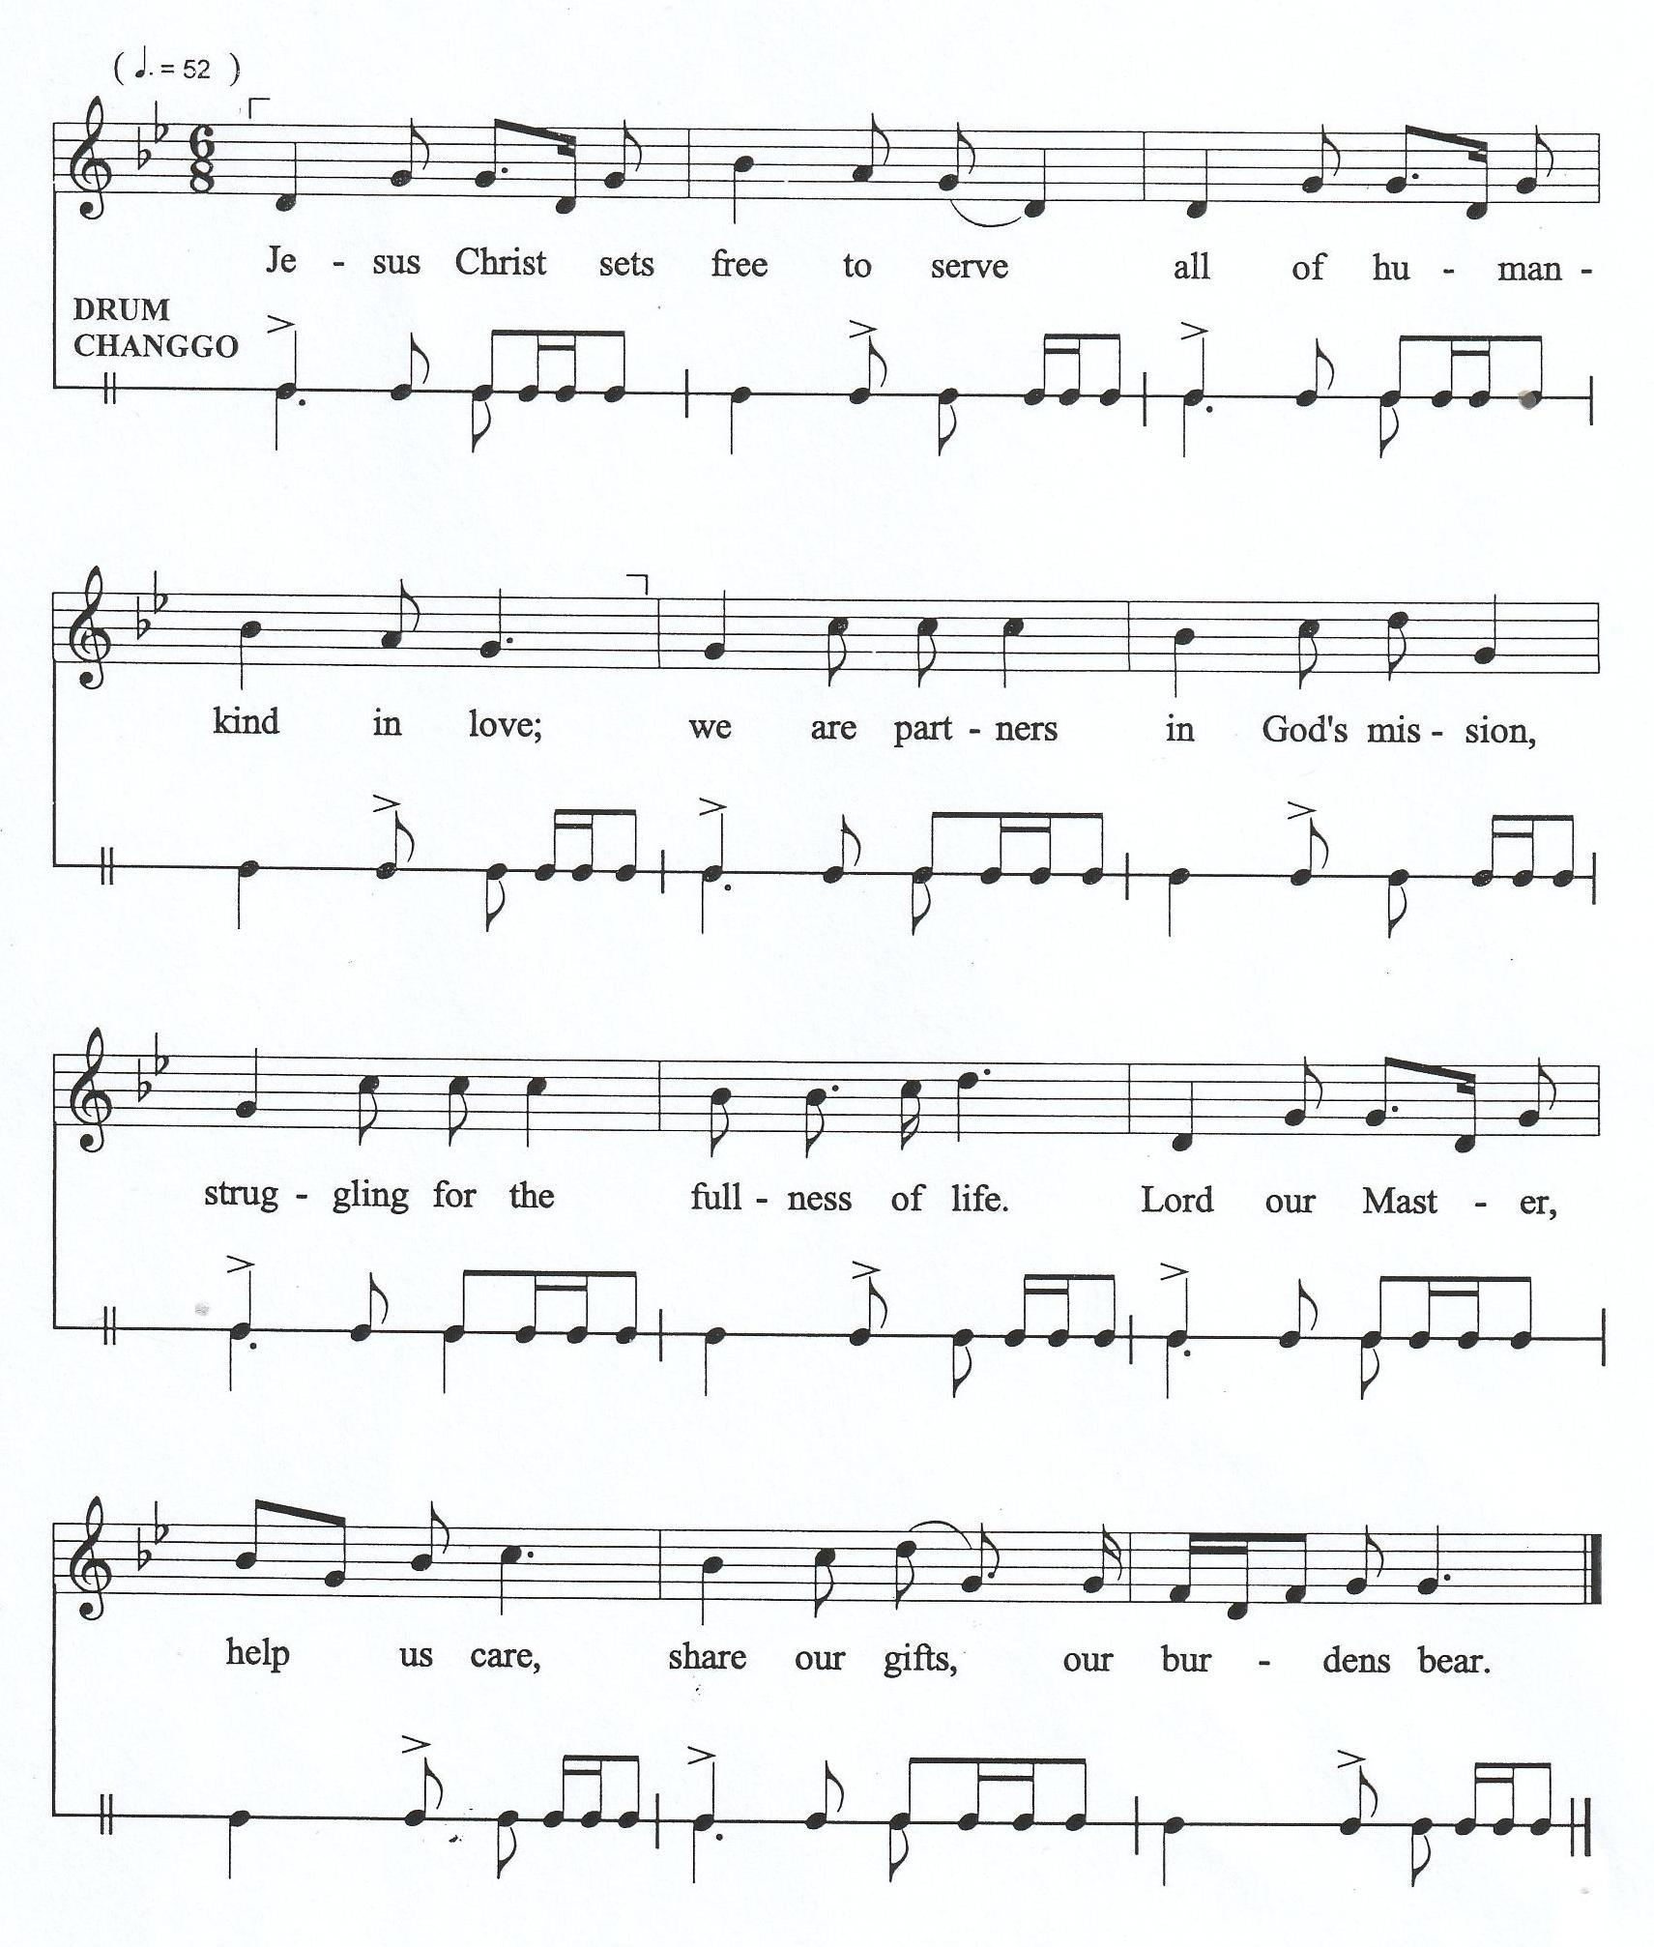

Sharing of God’s Peace
The mind ruled by the Spirit brings life and peace. (Romans 8: 6)
So let us do all we can to live in peace. And let us work hard to build up one another. (Romans 14:19)

(Sharing of Peace)

Prayer of Thanksgiving
Let heaven celebrate! Let the earth rejoice!
Let the sea and everything in it roar!
Let the countryside and everything in it celebrate!
Then all the trees of the forest too will shout out joyfully before the Lord because God is coming!
God is coming to establish justice on the earth!
God will establish justice in the world rightly.
God will establish justice among all people fairly.
For all You have done, we give thanks to You, God!

We adore You and praise You, God.
You fill and sustain everything around us;
With the touch of Your hand, You turned chaos into order.
You give form to everything, Lord of all creation.
We adore You and praise You, God. (Psalm 96:10-13)
For all You have done, we give thanks to You, God!

O Lord, how manifold are Your works!
In wisdom, You have made them all;
The earth is full of Your creations.
There is the sea, great and wide;
Creeping things innumerable are there, living things both small and great.
For all You have done, we give thanks to You, God!

O God, You have created everything by Your Hands,
For all You have done, we give thanks to You, God!
O God, You have gifted us with life and renewed all creation,
For all You have done, we give thanks to You, God!

For Your creation, the work of Your hands,
For nourishing us with food, water, air, the warmth of the sun, and all of nature’s gifts;
With grateful hearts, we give You thanks, O God!

For the life, the love, the care from the surroundings,
Bestowed upon Your people and the whole community;
With grateful hearts, we give You thanks, O God!

For the gifts of nature and the many lessons taught about integrity of creation and its sustainability,
For those who stand for the rights of the earth.
With grateful hearts, we celebrate You, O God, in all Your creation. (Psalm, 104:24-25)

- O Give Praise to Jesus, the King

Prayer for God’s Creation
God of life and peace,
we come before You, weary and burdened.
In our pain and suffering, we look to You, for You see us and know every tear we cry.
You are our refuge and strength, and in Your Spirit, we place our agonies and also hope.

God of life and peace,
We come before You holding the continent of Asia in our hearts.
We lift the millions who are groaning under the weight of oppression,
poverty, persecution, and hopelessness.
Lord, You have heard their cry, and we ask that You act on their behalf.
We pray for persecuted believers, especially in restricted nations, who face danger for their faith.
Give them supernatural strength, resilience, and courage,
and let them know that You are near in their silent, wordless cries.
We remember those in nations experiencing political turmoil, natural disasters, or extreme injustice.
Let Your justice and righteousness flow into these places like a mighty river.
For those whose hearts are broken, comfort them;
and for those who have no words left,
we ask the Holy Spirit to intercede with groans too deep for words.
Creator of all,
we remember that all that You have created has been groaning;
the created world continues to groan even now.
We also groan inside ourselves.

We remember we have failed to listen to the groans of the earth,
the groans of all creation, and the groans of the Spirit of hope that lives within us.

God of life and peace,
let Your Spirit help us in our weakness.
In our groaning and weakness, let Your strength be made perfect.
Draw us close to You, filling us with Your peace that revives our lives.

God of life and peace,
we ask that You reveal Your glory through our trials.
May our lives, even in suffering, be a testimony to Your love and faithfulness.
We trust You, the Rock that does not move.
We stand in awe of Your mercy, submitting ourselves fully to You in hope.

Scripture Readings

Isaiah 65:17-25
For I am about to create new heavens and a new earth; the former things shall not be remembered or come to mind. But be glad and rejoice forever in what I am creating, for I am about to create Jerusalem as a joy and its people as a delight. I will rejoice in Jerusalem and delight in my people; no more shall the sound of weeping be heard in it or the cry of distress. No more shall there be in it an infant who lives but a few days or an old person who does not live out a lifetime, for one who dies at a hundred years will be considered a youth, and one who falls short of a hundred will be considered accursed. They shall build houses and inhabit them; they shall plant vineyards and eat their fruit. They shall not build and another inhabit; they shall not plant and another eat, for like the days of a tree shall the days of my people be, and my chosen shall long enjoy the work of their hands. They shall not labour in vain or bear children for calamity, for they shall be offspring blessed by the Lord—and their descendants as well. Before they call, I will answer, while they are yet speaking, I will hear. The wolf and the lamb shall feed together; the lion shall eat straw like the ox, but the serpent—its food shall be dust! They shall not hurt or destroy on all my holy mountain, says the Lord.

Psalm 98:4-9
Make a joyful noise to the Lord, all the earth;
break forth into joyous song and sing praises.
Sing praises to the Lord with the lyre,
with the lyre and the sound of melody.
With trumpets and the sound of the horn
make a joyful noise before the King, the Lord.
Let the sea roar and all that fills it,
the world and those who live in it.
Let the floods clap their hands;
let the hills sing together for joy
at the presence of the Lord,
for he is coming to judge the earth.
He will judge the world with righteousness
and the peoples with equity.
Romans 8:19-23
For the creation waits with eager longing for the revealing of the children of God, for the creation was subjected to futility, not of its own will, but by the will of the one who subjected it, in hope that the creation itself will be set free from its enslavement to decay and will obtain the freedom of the glory of the children of God. We know that the whole creation has been groaning together as it suffers together the pains of labour, and not only the creation, but we ourselves, who have the first fruits of the Spirit, groan inwardly while we wait for adoption, the redemption of our bodies.

Luke 6:20-26
Then he looked up at his disciples and said:

“Blessed are you who are poor,
for yours is the kingdom of God.
Blessed are you who are hungry now,
for you will be filled.
Blessed are you who weep now,
for you will laugh.
Blessed are you when people hate you and when they exclude you, revile you, and defame you on account of the Son of Man. Rejoice on that day and leap for joy, for surely your reward is great in heaven, for that is how their ancestors treated the prophets.
But woe to you who are rich,
for you have received your consolation.
Woe to you who are full now,
for you will be hungry.
Woe to you who are laughing now,
for you will mourn and weep.
Woe to you when all speak well of you, for that is how their ancestors treated the false prophets.”

Sermon: “Hope for Redemption of Groaning Creation Amidst Bondage to Decay”
(Romans 8:19-23)

(Silent Meditation)

Offering

- For the Beauty of the Earth
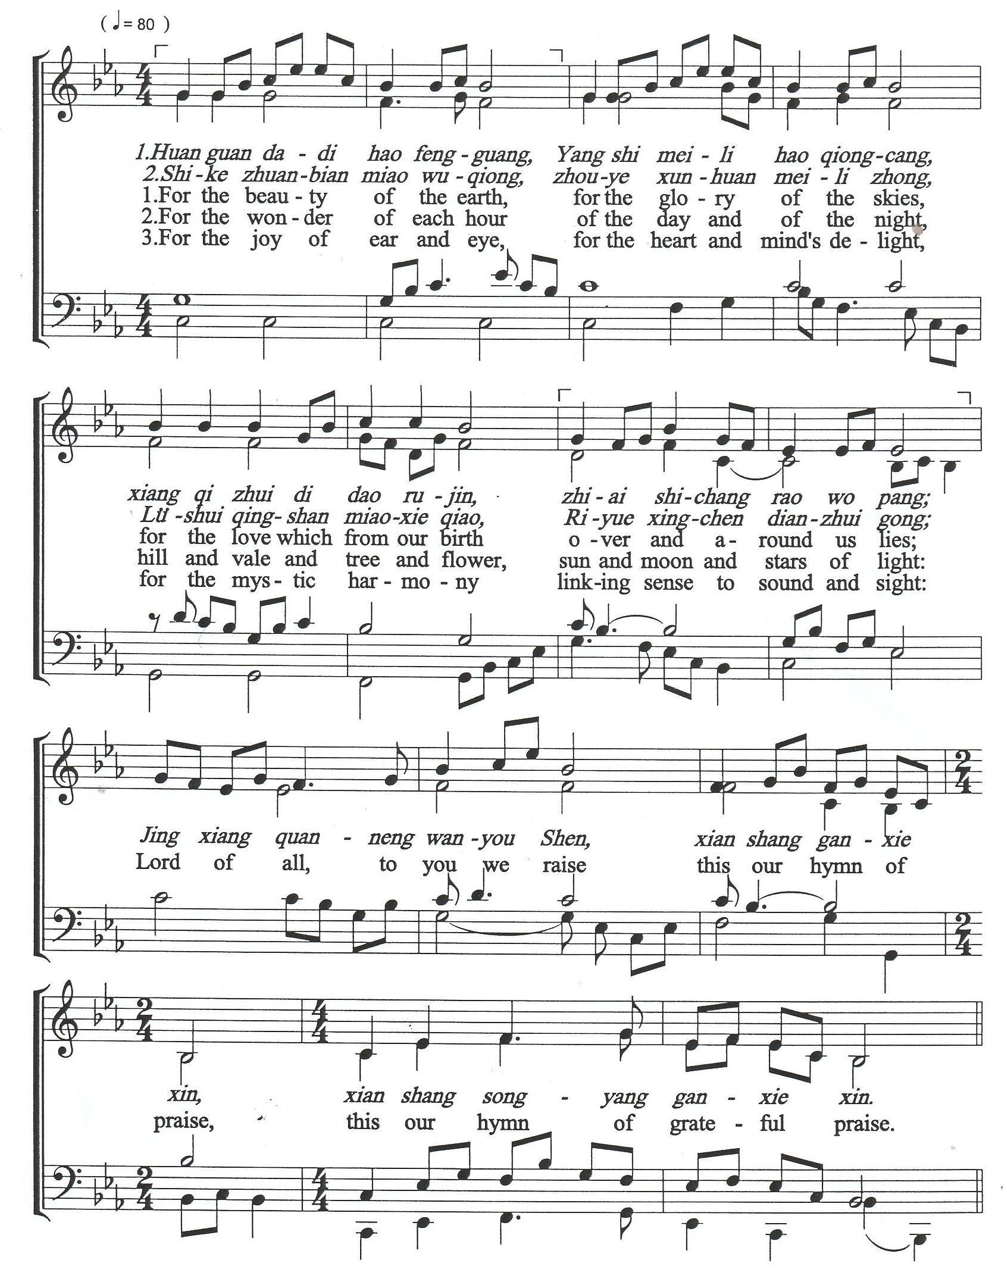

Prayer in Hope
Rejoice in hope, be patient in tribulation, be constant in prayer. (Romans 12:12)
God of hope,
We turn to You for hope.
You are the source of all hope and the light that shines in the darkness.
Your Word reminds us that You are our refuge and strength, an ever-present help in trouble.

God of hope, fill us with endurance today.
Hold our hearts and steady our feet.
Instead of placing our hope in better circumstances,
help us to find our hope in Your loving presence with us, guiding us and helping us.

Prayer for our Freedom and Salvation by the Spirit
We come before You, acknowledging our weakness.
There are moments when we truly do not know what we should pray for, or even how to speak.
We thank You that Your Holy Spirit intercedes for us with groans that words cannot express.
You, who search our hearts, know exactly what the Spirit is saying.
We find peace knowing the Spirit prays for us perfectly, according to Your divine will.

Holy Spirit, come to us today and renew our whole being.
Enkindle Your fire among us, within our communities, and within us.

Come, O quickly, O Holy Spirit. Come, we pray, unite our hearts.
Come, O quickly, O Holy Spirit. Come, we pray, increase our faith.

- O Come Quickly, Holy Spirit

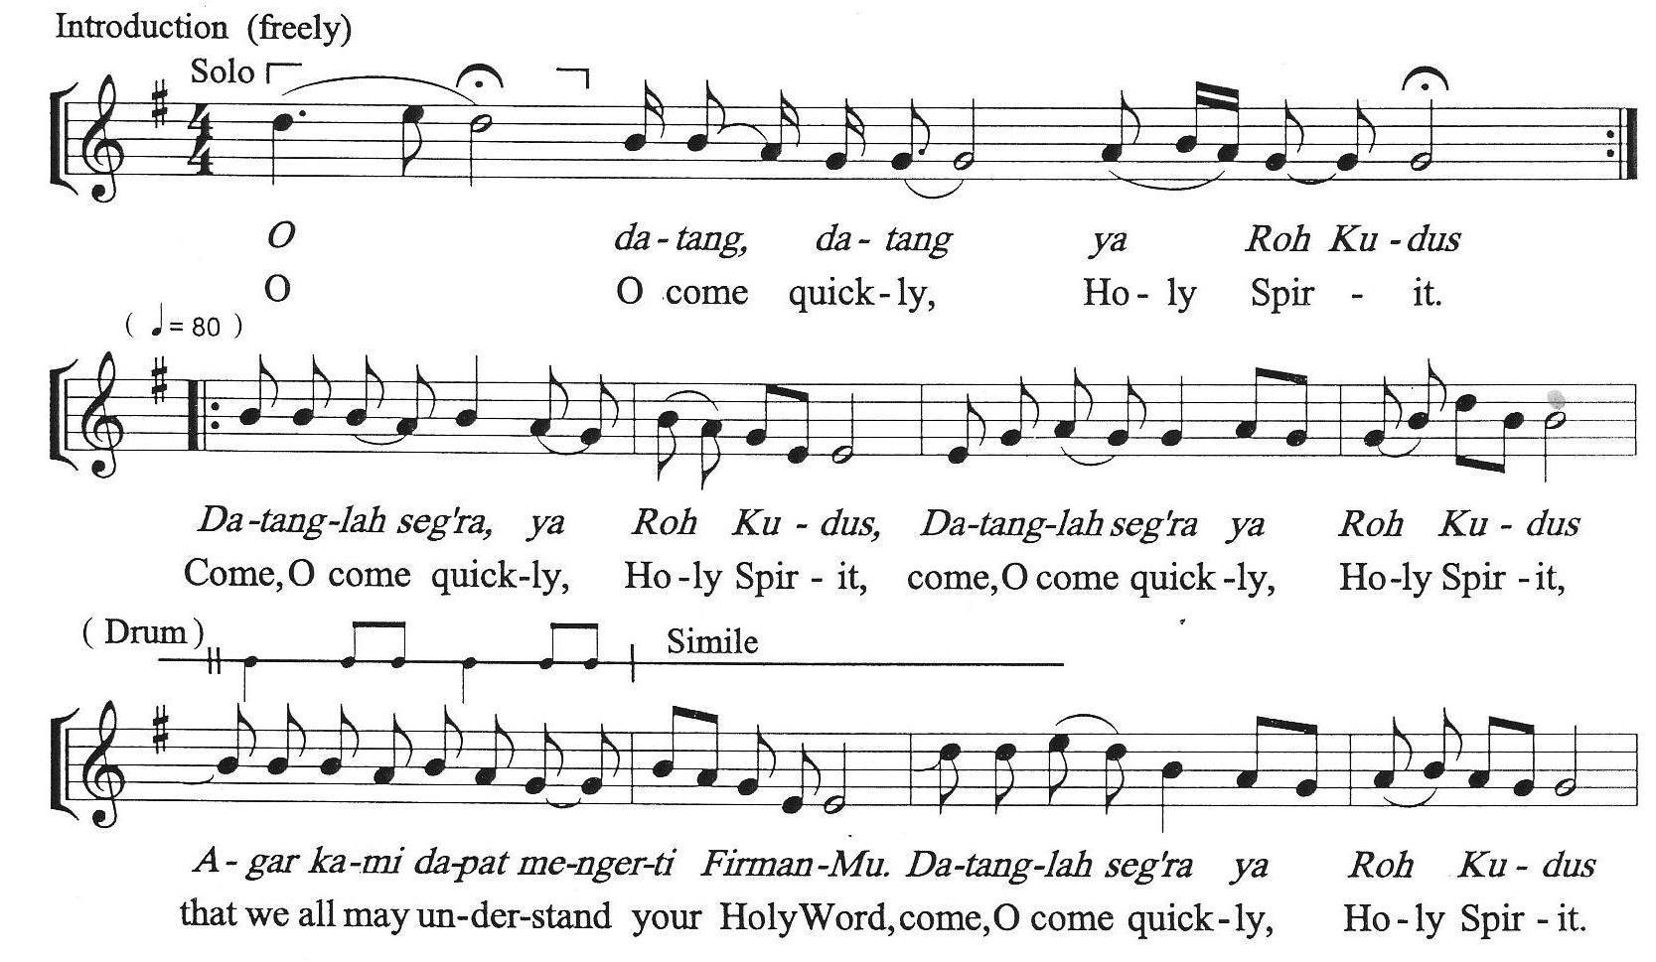

Prayer in Hope for Life and Peace
Merciful God,
We lift Your people across the world.
Many are walking through trials that test their faith:
Some are weary, some are afraid, and some are hungry.
We ask for Your protection over every believer.
Strengthen their hearts, provide their daily bread, and surround them with Your peace.

For those suffering from famine, bring relief.
For those longing for peace, bring them comfort.
For nations in conflict, raise up peacemakers and restore hope.
Let Your light shine in the darkest places.
Let Your love be known through Your people.

God of hope,
We are Your humble servants,
We come before You today longing for hope –
hope for love and kindness.
We pray for renewed life and peace.
Amen.

God of Justice,
We beseech You to be our helper and protector.
We pray for the people of Asia and around the world who are suffering from wars and hunger,
for those who are affected by illnesses and calamities,
and those who are affected by human trafficking,
domestic violence, statelessness, hate, discrimination, and indifference.
God of Love,
You hear our prayers.
We ask that You transform our prayers into action, our faith into witness,
and our hope into a source of strength for all who seek your presence.

May your Spirit continue to guide and inspire us as we journey together,
united in purpose and committed to your call.
Grant us grace to be living signs of your salvation,
reflecting your love and peace in every place we go.
May it be so!
Amen.

- God of Hope and Peace

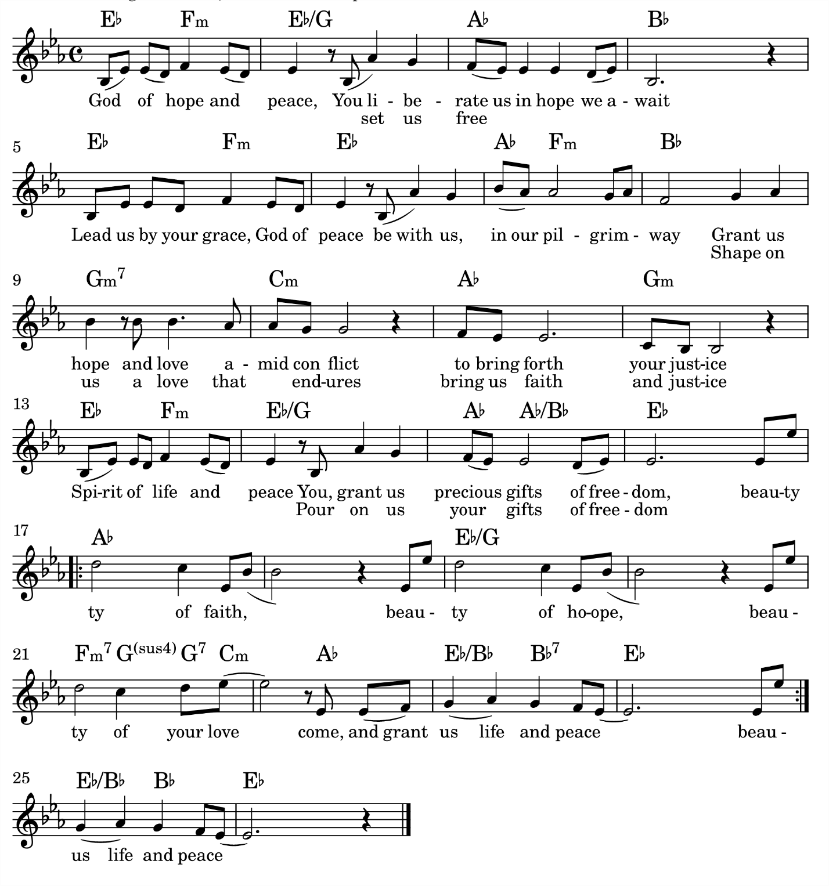
Theme Song of NCCK’s Centenary Celebration – 2024
Composed by RYU Hyung Sun
Words in English by Klein F Emperado and Grace Moon

Affirmation of Commitment
We commit ourselves to living out Your truths,
to lead with integrity,
to steward with justice,
and to serve with love.

We pledge to be responsible caretakers of all that God has entrusted to us,
the people, the resources, the earth, and the Church.

We will listen to the voices of the least and the lost,
and walk alongside communities in justice and compassion.

In the diverse and vibrant context of Asia,
we honour every culture and tradition that glorifies Christ,
and work in unity to build up the Body of Christ.
With God’s help, we will strive to be servant-leaders,
anchored in Scripture and guided by the Spirit.
May we be a witness to Your great mercy of redemption
and freedom from our bondage of sins.
Amen.

Sending Forth
Now may the God of hope fill us with life and peace in believing,
so that, by the power of the Holy Spirit, we may overflow with love and hope.
Thanks be to God.

The Spirit is our source of life.
Let us therefore walk by the Spirit.
Amen.

Blessing
May the Triune God
make us strong in faith and love,
make us free from the bondage to decay,
guide us on every side, and lead us in truth and peace;
and may the blessing of the God of life and peace
be among us and remain with us always.
Amen.

Postlude

